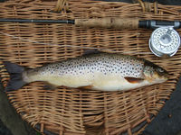


Wed 10th Aug Register by 10 am Aug
Categories are:
Best Fish (Senior) Best Fish Junior)
Best Basket (Senior) Best Basket (Junior)
£5 entry Fly and bank fishing only
Contact Thrumster House on 07840750407 or email enquiries@thrumstergamefair.co.uk

